GUIDELINE FOR FILLING IN A PURCHASE REQUEST
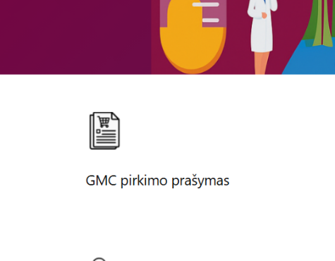

Submit the request here:
https://pagalba.vu.lt/plugins/servlet/desk/portal/55

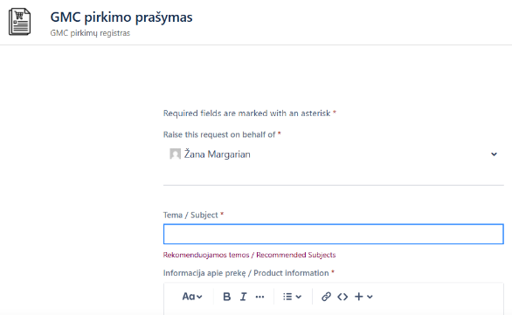
- Completing the Request

• Fill in all required fields marked with (*).

• Specify the type of funds.
(If the type of funds changes when the invoice is submitted for payment, it can be easily adjusted.)

• After agreeing on the purchase price with the supplier and receiving the offer or order agreement, upload the document to the request system.

Request Registration
- The request will be registered automatically.
- A registration number will be sent to your email: GMC-XXX

- Document Coordination with the Procurement Specialist
Coordination takes place individually with the procurement specialist assigned to you. Two scenarios are possible:
a) Purchase under an existing contract
- The procurement specialist uploads the contract to “Avilys” for signature.
- If no contract signatory is specified, the contract is signed by the procurement specialist.
- In the Jira system, the request status is changed to PURCHASE CONFIRMED (this means the contract has been signed and the supplier may begin fulfilling the order).
- If the purchase is based on a contract but no order agreement is required, please indicate in the notes whether the purchase has already been coordinated with the supplier and/or whether you need the procurement specialist to confirm the order and place it.
- Once the purchase is coordinated and the items are ordered, the request status in Jira will be updated to PURCHASE CONFIRMED (PIRKIMAS PATVIRTINTAS)

b) Purchase Based on a Submission
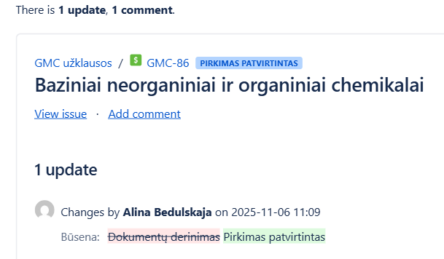
- The procurement specialist completes the purchase submission if the request contains sufficient information.
- If any information is missing, the specialist will contact you for additional details or clarification.
- Once the submission is approved and the procurement method is determined, the request status will change to PURCHASE CONFIRMED.
- You will receive an email notification with the purchase number.

- Receipt of Goods
- We will inform you once the goods are received.
- If the goods are delivered not directly to you but to a designated receiving point, you will also receive a notification about this.

Invoice Submission and Request Closure
- To close the request, the invoice must be submitted for payment.
- If you receive the invoice yourself, upload it to the system under the same request.
- If you forward the invoice to your administrator, clearly indicate the request number on the invoice (e.g., GMC-123).
- The procurement specialist uploads the invoice to the VIPĮ system for payment.
- After this, the request is closed.

Note
If you have any questions regarding how to complete the request or about its status, please contact your procurement specialist.

